Section 1: Case Summary

Scenario Title: | Back Pain and Hypertension
Keywords: | Aortic dissection, bedside ultrasound, agitated patient, back pain
Brief Description of Case: | A 53 year old male with untreated hypertension presents with a history of vomiting, back pain and acute agitation. Once he is sedated, assessment will reveal an acute aortic dissection. He will require prompt treatment, intubation and disposition planning.

Goals and Objectives
Educational Goal: | To diagnose and treat acute aortic dissection complicated by agitation
Objectives:  (Medical and CRM) | - Recognize and manage the agitated, critically ill patient  - Utilize clinical assessment and physical examination for aortic dissection  - Utilize bedside ultrasound in diagnosing an aortic dissection  - Appropriately manage hemodynamics in the setting of an aortic dissection  - Prepare the medical team for a worst-case-scenario event
EPAs Assessed:

Learners, Setting and Personnel
Target Learners: | ☒ Junior Learners |  | ☒ Senior Learners |  |  | ☒ Staff
 | ☒ Physicians | ☒ Nurses |  | ☐ RTs | ☐ Inter-professional
 | ☐ Other Learners:
Location: | ☒ Sim Lab |  | ☐ In Situ |  |  | ☐ Other:
Recommended Number of Facilitators: | Instructors: 1
 | Confederates: 1
 | Sim Techs: 1

Scenario Development
Date of Development: | 26/08/2020
Scenario Developer(s): | Lubna Saffarini (main author), Chafika Lasfer (case reviewer), Yasser Armaghan (case reviewer)
Affiliations/Institutions(s): | Dubai Health Authority
Contact E-mail: | Saff.lubna@gmail.com
Last Revision Date:
Revised By:
Version Number: | 1

Section 2A: Initial Patient Information

- Patient Chart
Patient Name: B.D. |  |  |  | Age: 53 | Gender: M | Weight: 90kg
Presenting complaint: vomiting and back pain after having a meal
Temp: afebrile | HR:130 | BP: 240/120 |  | RR: 16 | O₂Sat: 96% | FiO₂: Room air
Cap glucose: normal (to be given only when asked) |  |  |  | GCS: 11 (E4, V2, M5)
Triage note:
53 year old male with uncontrolled hypertension and sudden onset back pain and non-bloody vomitus. Brought in by paramedics to the resuscitation area very agitated and combative with a BP reading of 240/120. He has a normal blood glucose. No history of seizures, loss of consciousness, fever, or substance use.
Allergies: None
Past Medical History:  Hypertension |  |  | Current Medications:  Nil

Section 2B: Extra Patient Information

A. Further History
Include any relevant history not included in triage note above. What information will only be given to learners if they ask? Who will provide this information (mannequin’s voice, confederate, SP, etc.)?

Paramedics:

We have placed one large bore IV

Nurse:

No medical records are available on the system

Mannequin:

Moans when approached and is combative despite efforts at physical restraint

B. Physical Exam
List any pertinent positive and negative findings
Cardio:  - S1 + S2, no murmurs  - Pulses in upper limbs: delayed and weak on the right side  - Pulses in the lower limbs: delayed and weak on the right side | Neuro:  - pupils 2 mm, reactive  - GCS: 11 (E4, V2, M5)
Resp:  - equal bilateral air entry, no added sounds | Head & Neck:  - no neck stiffness
Abdo:  - soft, no masses | MSK/skin: (to be given only if asked)  - upper limbs: cold and clammy on the right, warm on the left  - lower limbs: bilaterally cold
Other: nil

Section 3: Technical Requirements/Room Vision

A. Patient
☒ Mannequin (specify type and whether infant/child/adult): adult
☐ Standardized Patient
☐ Task Trainer
☐ Hybrid
B. Special Equipment Required
Personal protective equipment
Airway kit – including video laryngoscopy, LMA, bougie
Cardiac monitor, defibrillator with pads
IV lines
SpO2 monitor
Bedside ultrasound
Capnography

C. Required Medications
Benzodiazepine, esmolol, labetalol, nicardipine, propofol, fentanyl, midazolam, etomidate, ketamine, epinephrine, ACLS medications

D. Moulage
Agitated, restless, and a combative patient

E. Monitors at Case Onset
☐ Patient on monitor with vitals displayed
☒ Patient not yet on monitor
F. Patient Reactions and Exam
Include any relevant physical exam findings that require mannequin programming or cues from patient
(e.g. – abnormal breath sounds, moaning when RUQ palpated, etc.) May be helpful to frame in ABCDE format.

A: patent, patient is moaning
B: equal bilateral air entry, no added sounds
C: pulses in upper limbs: delayed and weak on the right side, pulses in the lower limbs: delayed and weak on the right side
D: GCS 11 (E4, V2, M5), pupils 2mm nonreactive
E: restless and agitated, no signs of trauma or external bleeding

Section 4: Actors and Standardized Patients

Actors and Standardized Patient Roles and Scripts
Role | Description of role, expected behavior, and key moments to intervene/prompt learners. Include any script required (including conveying patient information if patient is unable)
Paramedic | - When asked about further history:  “We don’t have any further history except that he is hypertensive and not on any medications”  “His family are on the way and we don’t have any number to contact them”
Nurse | - When learner asks for IV lines, cardiac monitor, set of vitals, ECG…etc:  “The patient is very restless and agitated and it is difficult to commence those orders”  - If learner delays chemical restraint:  “Doctor, should we attempt to restrain the patient?”  - BP should only be provided from the left arm until asked for bilateral BPs  - If learner asks about previous medical records:  “None are available”
Cardiothoracic and ICU doctors | - When learner consults the Cardiothoracic and ICU doctors.  “Thank you for your consult. Please target blood pressure to a goal of less than 120 SBP and HR less than 60 bpm and go ahead with intubation, we will be on our way. Please also have an arterial line placed for blood pressure monitoring.”

Section 5: Scenario Progression

Scenario States, Modifiers and Triggers
Patient State/Vitals | Patient Status | Learner Actions, Modifiers & Triggers to Move to Next State |  | Facilitator Notes
1. Baseline State  Unable to place on monitor  Per EMS:  HR: 130  BP: 240/120 (left)  RR: 24  O₂SAT: 96% RA | Agitated, restless, not allowing staff to attach monitor or re-measure vitals  Patient has 1 IV line inserted by paramedics | Expected Learner Actions  Apply personal protective equipment  Consider physical/chemical restraint (benzodiazepine, etomidate, etc)  Consider analgesia (fentanyl etc)  Consider airway management | Modifiers  Changes to patient condition based on learner action  - Sedation not given nurse to suggest physical restraint at 3 min  Triggers  For progression to next state  - Sedation given 2. Sedated  - Sedation not given within 5 minutes 5. VT Arrest
2. Sedated  Rhythm: sinus  HR: 110  BP: 200/100 (left)  RR: 16  O2SAT: 100% NRB  T: afebrile  GCS: 9 (E3 V2 M4) | Patient sedated | Expected Learner Actions  Assess ABCDEs  2 large bore IV lines, cardiac monitor  ECG  Full set of vitals (bilateral BP)  Orders for blood collection  Chest x-ray  Orders for intubation kit, difficult airway kit and back up to be notified in case of intubation | Modifiers  Triggers  - All actions complete 3. Investigation  - Use of any vasodilator before rate control 5. VT Arrest
3. Investigation  Rhythm: sinus  HR: 110  BP: 200/100 (left)  117/66 (right)  RR: 16  O₂SAT: 100% NRB | Patient sedated  Family not available | Expected Learner Actions  Perform full primary and secondary survey including recognition of discrepancy in pulses or BP  Bedside US: abdo aorta  Bedside US: pericardium  Interpret ECG  Interpret CXR  Start empirical IV beta blocker followed by vasodilator  Order CT aortogram | Modifiers  - Beta blocker followed by vasoactive infusion started BP reading on the left side remains 180/95  Triggers  - Beta blocker started 4. Agitation  - No beta blocker by 10 min or starting vasoactive infusion prior to beta blocker 5. VT Arrest | It is expected from the learner to verbalize titration of the cardiac/vasoactive meds along with the goal SBP and pulse
4. Agitation | Patient becomes restless  Nurses cannot control the patient and he is resisting the efforts of the staff to restrain him | Expected Learner Actions  Recognize that the patient needs emergent intubation and prepare for intubation with back up and the difficult airway kit  RSI intubation  Post-intubation sedation  Post-intubation orders: attach to ventilator, capnography, foley and chest x-ray  Cardiothoracic surgery and ICU consult | Modifiers  Post-intubation: BP 110/65, Pulse 45, O2 sat 98%  Triggers  - Unsafe intubation 5. VT Arrest  - Successful intubation and consult END CASE  - No intubation by 12 minutes 5. VT Arrest  - If learner uses ketamine at any point 5. VT Arrest (due to sympathomimetic effect)
5. VT Arrest  Rhythm: VT  HR 180 (no pulse)  BP --/--  RR –  O₂SAT: -- | Patient is unresponsive and pulseless | Expected Learner Actions  High quality CPR  Team leadership and task assignment  Early defibrillation  Consider Epinephrine every 3 – 5 minutes  Correction of Hs&Ts  Advanced airway  Monitor capnography  ACLS protocol | Modifiers  Triggers  - After shock x1 return to previous state

Appendix A: Laboratory Results

Nil

Appendix B: ECGs, X-rays, Ultrasounds and Pictures

Paste in any auxiliary files required for running the session. Don’t forget to include their source so you can find them later!
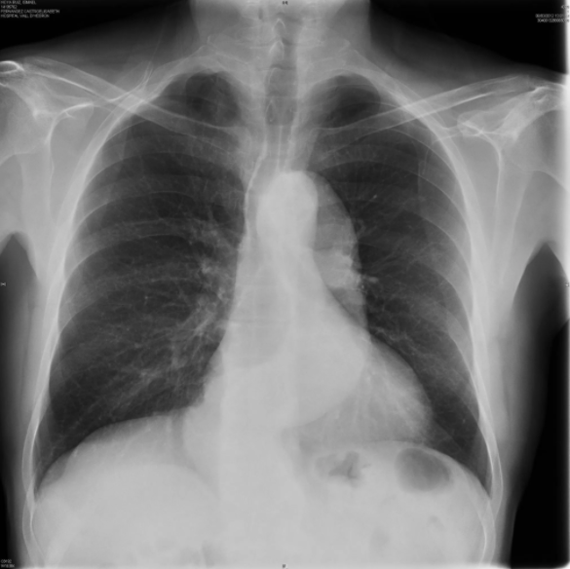
Source = https://www.flickr.com/photos/iem-student/28434522267/
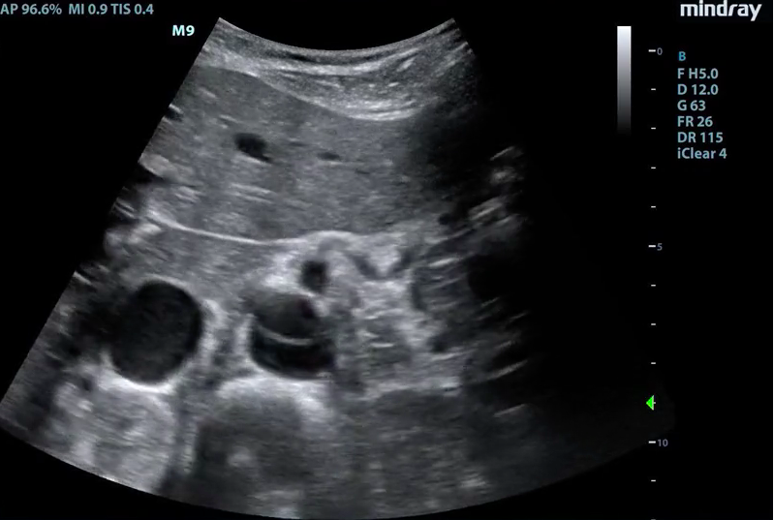
Source = https://www.coreultrasound.com/uotw-80-answer/
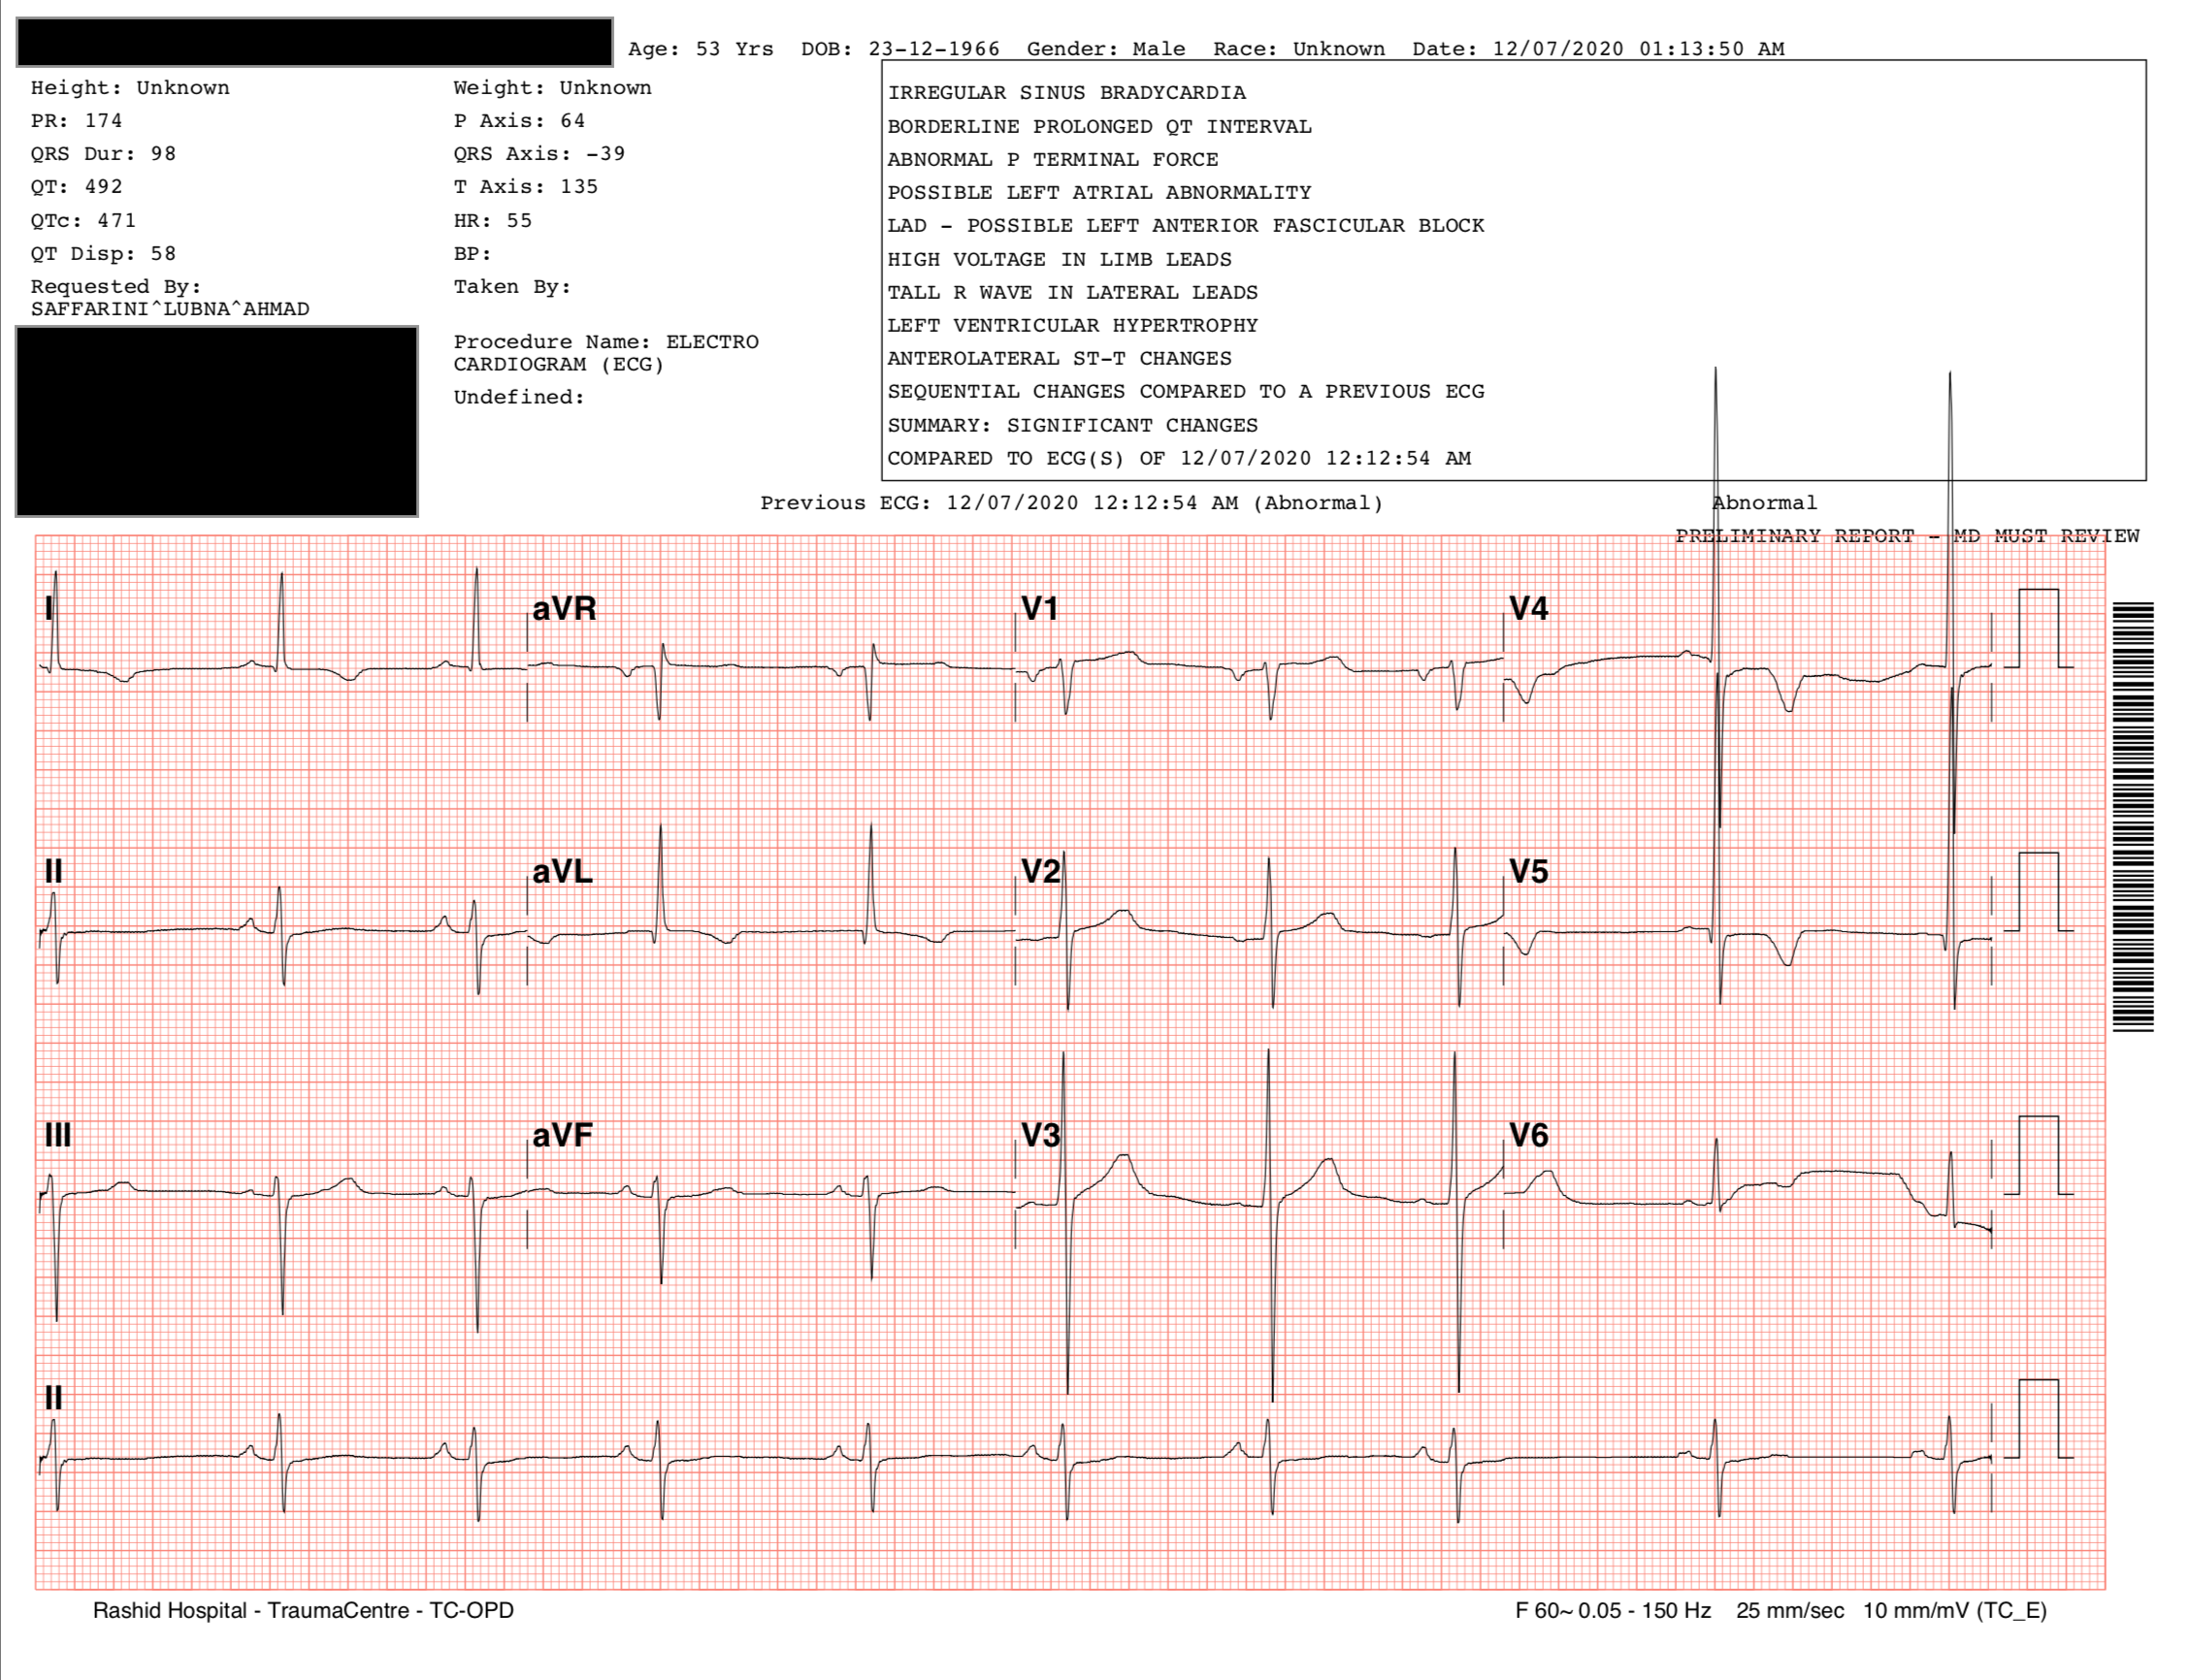

Appendix C: Facilitator Cheat Sheet & Debriefing Tips

Include key errors to watch for and common challenges with the case. List issues expected to be part of the debriefing discussion. Supplemental information regarding any relevant pathophysiology, guidelines, or management information that may be reviewed during debriefing should be provided for facilitators to have as a reference.

Key moments to reflect on:
- Bedside glucose stat in an agitated patient
- Appropriate chemical restraint of an agitated patient
- Clinical assessment and focused physical examination in suspected an aortic dissection (pulse deficit, bilateral BP)
- Bedside ultrasound in diagnosing an aortic dissection and recognizing the flap
- Appropriate management of an aortic dissection and setting clear goals
- Reassessment of patient and follow up of vital signs and appropriate medication titration and choice
- Response to sudden change in patient status and emergency intubation with appropriate medication choice
- Response to the deterioration of the patient and ACLS protocol
- Importance of involving both the Cardiothoracic and Vascular Surgery teams

Debriefing discussion:
- May you summarize the case?
- Can you describe what happened, note challenges met and how you overcame them?
- At what point did you suspect the diagnosis of aortic dissection?
- What is the differential diagnosis for this presentation?
- Mention the positive and negative aspects of the code?
- What is a significant blood pressure difference between 2 arms (> 20 mmHg)? And what is the percentage of patients presenting to the ED with this difference without a dissection (19%)?
- What is the percentage of hypertension (49%) and hypotension (18% - 25%) as a presenting finding? Which one holds a worse prognosis (hypotension)?
- What are expected ECG findings in an aortic dissection (abnormal ECG findings include new Q waves or ST segment elevation in 3% to 4%, ST-segment depression in 15% to 22%, and nonspecific ST- and T-wave changes in 41% to 62%, and the ECG is normal in only 19% to 31% of patients)?
- What is the BP and pulse targets (target SBP of 100 to 120 and a heart rate less than 60 bpm are recommended)?
- What is the appropriate choice of medications and contraindications? (check references below)
- What is the role of vasodilators (they may be added for further antihypertensive treatment after successful administration of beta blockers)?
- What is the role of bedside ultrasound in diagnosing an abdominal aortic dissection (check references below)?
- If the patient was hypotensive, what would change in the management (check for a tamponade, give IV fluids, blood transfusion)?

References

1. Tintinalli’s Emergency Medicine – 9th Edition (Chapter 59 – Section 7, Chapter 29A – Section 4)
2. Rosen’s Emergency Medicine – 9th Edition (Chapter 75 – Section 3)
3. Abdominal Aortic Aneurysm, Life in the Fast Lane (March 2019): https://litfl.com/abdominal-aortic-aneurysm-aaa/
4. https://www.emra.org/emresident/article/cant-miss-killer-the-role-of-point-of-care-ultrasound-in-diagnosing-acute-aortic-dissection/
5. https://www.coreultrasound.com/uotw-80-answer/

